### 

### Semester Two Examination, 2022

### Question/Answer booklet

# MATHEMATICS METHODS

**UNIT 3 & 4**

## Section Two:

## Calculator-assumed

|  |  |
| --- | --- |
| **Your Name:** |  |
| **Your Teacher’s Name:** |  |

## Time allowed for this section

Reading time before commencing work: ten minutes

Working time: one hundred minutes

## Materials required/recommended for this section

***To be provided by the supervisor***

This Question/Answer booklet

Formula sheet (retained from Section One)

***To be provided by the candidate***

Standard items: pens (blue/black preferred), pencils (including coloured), sharpener, correction fluid/tape, eraser, ruler, highlighters

Special items: drawing instruments, templates, notes on two unfolded sheets of A4 paper, and up to three calculators approved for use in this examination

## Important note to candidates

No other items may be taken into the examination room. It is **your** responsibility to ensure that you do not have any unauthorised material. If you have any unauthorised material with you, hand it to the supervisor **before** reading any further.

|  |  |  |  |  |  |
| --- | --- | --- | --- | --- | --- |
| Question | Marks | Max | Question | Marks | Max |
| 7 |  | 5 | 13 |  | 9 |
| 8 |  | 8 | 14 |  | 8 |
| 9 |  | 9 | 15 |  | 13 |
| 10 |  | 7 | 16 |  | 7 |
| 11 |  | 10 | 17 |  | 16 |
| 12 |  | 7 |  |  |  |

**Structure of this paper**

|  |  |  |  |  |  |
| --- | --- | --- | --- | --- | --- |
| Section | Number of questions available | Number of questions to be answered | Working time (minutes) | Marks available | Percentage of examination |
| Section One:  Calculator-free | 6 | 6 | 50 | 49 | 33 |
| Section Two:  Calculator-assumed | 11 | 11 | 100 | 99 | 67 |
|  |  |  |  | **Total** | 100 |

**Instructions to candidates**

1. The rules for the conduct of the Western Australian Certificate of Education ATAR course examinations are detailed in the *Year 12 Information Handbook 2019*. Sitting this examination implies that you agree to abide by these rules.
2. Write your answers in this Question/Answer booklet.
3. You must be careful to confine your answers to the specific questions asked and to follow any instructions that are specific to a particular question.
4. Additional pages for the use of planning your answer to a question or continuing your answer to a question have been provided at the end of this Question/Answer booklet. If you use the space to continue an answer, indicate in the original answer space where the answer is continued, i.e. give the page number.
5. **Show all your working clearly.**Your working should be in sufficient detail to allow your answers to be checked readily and for marks to be awarded for reasoning. Incorrect answers given without supporting reasoning cannot be allocated any marks. For any question or part question worth more than two marks, valid working or justification is required to receive full marks. If you repeat any question, ensure that you cancel the answer you do not wish to have marked.
6. It is recommended that you **do not use pencil**, except in diagrams.
7. The Formula sheet is **not** to be handed in with your Question/Answer booklet.

**Section Two: Calculator-assumed (99 Marks)**

This section has **eleven** questions. Answer **all** questions. Write your answers in the spaces provided.

Spare pages are included at the end of this booklet. They can be used for planning your responses and/or as additional space if required to continue an answer.

● Planning: If you use the spare pages for planning, indicate this clearly at the top of the page.

● Continuing an answer: If you need to use the space to continue an answer, indicate in the original answer space where the answer is continued, i.e. give the page number. Fill in the number of the question that you are continuing to answer at the top of the page.

Working time: 100 minutes.

**Question 7 (5 marks)**

The time, *T* minutes, for a group of University students to complete a Mathematics task is

assumed to be normally distributed.

It is known that 3% of students complete the task in at least 32 minutes, while 0.2% complete

the task in less than 15 minutes.

Determine the mean and standard deviation of *T*. (5 marks)

**Question 8 (8 marks)**

A car insurance company models claims it pays out with a random variable $*X*

which has a probability density function defined to be:

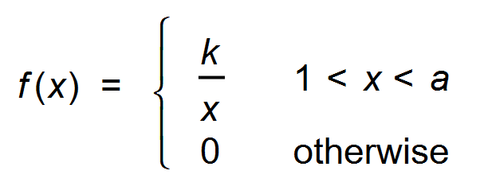

The median claim is $500.

(a) Show that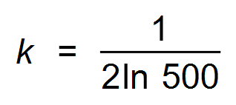 . (3 marks)

(b) Determine what percentage of claims are less than $2500. (2 marks)

(c) The car insurance company determines that 6% of their clients submitted a claim in

the past year. A sample of 320 clients is randomly selected. Describe and state the parameters of the sampling distribution of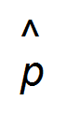, the sample proportion of clients who submitted a claim in the past year. (3 marks)

**Question 9 (9 marks)**

The score when a spinner is spun is given by the discrete random variable X with the following probability distribution, where a and b are probabilities.

|  |  |  |  |  |  |
| --- | --- | --- | --- | --- | --- |
| *x* | – 1 | 0 | 2 | 4 | 5 |
| P(*X* = *x*) | *b* | *a* | *a* | *a* | *b* |

(a) Explain why E(X ) = 2. (1 mark)

(b) Given that Var(X ) = 7.1, determine the probabilities a and b. (3 marks)

The discrete random variable Y = 10 – 3X.

(c) Find the following:

(i) E(Y ) (1 mark)

(ii) Var(Y ) (1 mark)

(d) The spinner is spun once. Find P(Y > X). (3 marks)

Question 10 (7 marks)

The manager of a swimming pool wanted to confirm their estimate that $25\%$ of local school students visited the pool at least once a month. The manager considered the following three ways of selecting a sample:

A Create an online survey and publish a link to it in the local newspaper.

B Visit local homes chosen at random and ask students who live there.

C Ask students who turn up to the pool after school.

(a) Briefly discuss a source of bias in each sampling method and suggest a better sampling procedure. (4 marks)

(b) It was found that $42$ out of a random sample of $120$ students visited the centre at least once a week. Determine the $95\%$ confidence interval for the proportion based on this data and use it to comment on the manager's estimate. (3 marks)

Question 11 (10 marks)

An online retailer of auto parts knows that on average, $18.5\%$ of parts sold will be returned.

(a) Let the random variable $X$ be the number of parts returned when a batch of $88$ parts are sold.

(i) Describe the distribution of $X$. (2 marks)

(ii) Determine the probability that less than $15\%$ of the parts sold in this batch will be returned. (2 marks)

The retailer takes a large number of random samples of $150$ parts from its sales data and records the proportion $\hat{p}$ of returned parts in each sample. Under certain circumstances, the distribution of $\hat{p}$ will approximate normality.

(b) Explain why the retailer can expect the distribution of $\hat{p}$ to closely approximate normality in this case. (3 marks)

(c) State the parameters of the normal distribution that $\hat{p}$ approximates and use this distribution to determine the probability that the proportion of returns in a random sample of $150$ parts is less than $15\%$. (3 marks)

Question 12 (7 marks)

<EFOFEX>
id:fxd{4e05fab1-be1a-4358-b3e3-bce017f9fc8d}

FXData:
</EFOFEX>Functions $f, g$ and $h$ are defined by

$$f\left(x\right)=10\cos\left(\frac{πx}{5}\right)-20 \\ g\left(x\right)=-10\cos\left(\frac{πx}{5}\right) \\ h\left(x\right)=10-4x.$$

The graphs of these functions  
are shown to the right.

(a) Determine the area between $y=f(x)$, the $x$-axis, $x=3.75$ and $x=5$. (3 marks)

(b) Determine the area of the shaded region enclosed by the three functions. (4 marks)

Question 13 (9 marks)

In a random sample of $225$ adult female Australians, $72$ were born overseas. This data is to be used to construct a $90\%$ confidence interval for the proportion of adult female Australians born overseas.

(a) Determine the margin of error for the $90\%$ confidence interval. (3 marks)

(b) State the $90\%$ confidence interval. (1 mark)

(c) The $90\%$ confidence interval for the proportion of adult male Australians born overseas constructed from another random sample was $(0.288, 0.412)$. Determine the number of adult males who were born overseas in this sample. (5 marks)

**Question 14 (8 marks)**

To stop the spread of Covid it is advised to cover your nose when sneezing.

When humans sneeze the speed of the droplets expelled decrease at a constant rate of ms-2.

(a) Clearly show that $v\left(t\right)=-3t+c$. (2 marks)

(b) Determine, in terms of $c$, how long it takes the droplets to come to rest. (1 mark)

(c) (i) Write down an integral expression for $d$, the distance travelled by the droplets  
 from $t=0$ until they come to rest. (2 marks)

(ii) The *New Scientist* magazine reported in 2020 that some droplets in a sneeze can  
 travel upwards of $8$ m.  
  
 Use your answer to part (c)(i) to find the initial speed of a sneeze,  
 correct to two decimal places. (3 marks)

**Question 15 (13 marks)**

Current Australian standards currently recommend the maximum ambient noise level for an empty classroom is $45$ dB.

Acoustic consultants tested the ambient noise level in the classrooms of a newly built school.

Their results are shown in the relative frequency histogram below.

<EFOFEX>

id:fxd{73320775-6584-43e4-a86f-07bd033b0f9b}


FXData:

</EFOFEX>

(a) Determine the proportion of classrooms that fail to meet the standard. (1 mark)

(b) Determine the probability that a classroom had an ambient noise level greater  
than $42.5$ dB, given that it has an ambient noise level within $10$ dB of the standard. (3 marks)

(c) Describe one feature of the histogram that supports using a normal distribution  
to model the ambient noise levels. (1 mark)

For the data, the mean ambient noise level is $37.3$ dB and the standard deviation is $7.1$ dB.

(d) (i) Using a normal distribution determine the probability a classroom has an  
 ambient noise level of between $30$ and $45$ dB. (1 mark)

(ii) Using the histogram on last page, determine the probability that a classroom as an  
 ambient noise level of between $30$ and $45$ dB, and explain whether this supports  
 using a normal distribution to model this data. (2 marks)

Assuming the data can be modelled using a normal distribution with a mean of $37.3$ dB and the standard deviation of $7.1$ dB, determine

(e) the value to which the mean ambient noise level would have to be reduced in  
order to ensure that at most $2\%$ of the classrooms would fail to meet the standard.  
Assume that the standard deviation remains unchanged. (3 marks)

High school students spend 45-75% of their time in the classroom listening to their teacher or classmates. Hence, classrooms can be prone to high noise levels. The noise levels inside a large number of busy classrooms were found to be normally distributed with a mean of $68$ dB, and variance of $16$ dB.

(f) Write a number in each box to provide to indicate the scale of the distribution. (2 marks)

<EFOFEX>

id:fxd{1d5236c3-492e-4dbe-a662-4491d68846a1}


FXData:


</EFOFEX>

**Question 16 (7 marks)**

<EFOFEX>

id:fxd{fde4641d-53ea-494b-900c-45201a35ba12}


FXData:


</EFOFEX>

The family of curves with equation $y=a^{x}$  
where $a>0$, are exponential curves, and are  
shown at right.

For each of these curves the value of $\frac{dy}{dx}÷y$ is constant for all values of .

<EFOFEX>

id:fxd{aa844b47-1c2c-4801-8cd4-cd8d606472a4}


FXData:


</EFOFEX>  
  
  
  
The values of $\frac{dy}{dx}÷y$ are graphed at right for different bases $a$.

Using first principles $\frac{dy}{dx}÷y$ can be written as:

$$\frac{dy}{dx}÷y=\frac{a^{x}\left(\lim_{h→0}\frac{a^{h}-1}{h}\right)}{a^{x}}=\lim_{h→0}\frac{a^{h}-1}{h}$$

(a) State the value of $a$, for which $\lim_{h→0}\frac{a^{h}-1}{h}=1$. (1 mark)

The axes below show the graphs of $y=x$ and $y=e^{-x+1}$.

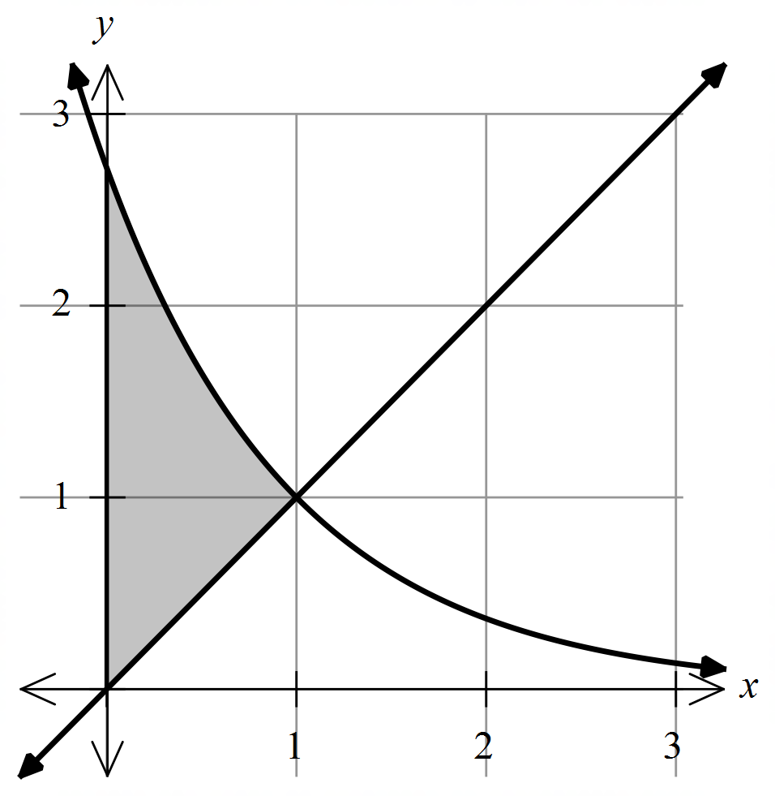

(b) Show that the two graphs intersect when $x=1$. (1 mark)

(c) Determine the exact shaded area shown on the graph. (3 marks)

The axes below show the graphs of $y=x$ and $y=1-\ln{x}$. The graph of $y=e^{-x+1}$ is included as a dotted line.

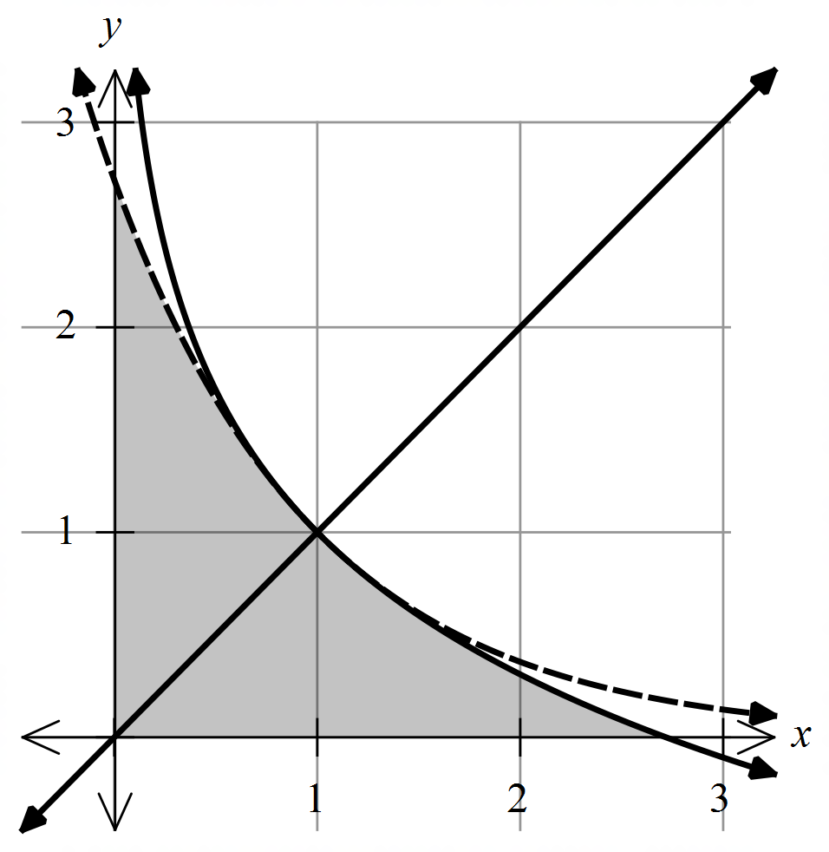

(d) Determine the exact shaded area shown on the graph, justifying your answer. (2 marks)

**Question 17 (16 marks)**

A 2019 survey of 1000 Australians aged 14 and above found that 637 people in the sample indicated that they ate take away food at least once a week.

(a) Determine the sample proportion for this sample. (1 mark)

The survey report included a $95\%$ confidence interval for the population proportion of Australians who ate take away food at least once a week.

(b) (i) Complete the boxes below to form a $95\%$ confidence interval for the population  
 proportion of Australians who ate take away food at least once a week. (2 marks)

|  |  |  |  |  |  |  |  |
| --- | --- | --- | --- | --- | --- | --- | --- |
| $$0.637-$$ |  | $$×$$ |  | $$≤p≤0.637+$$ |  | $$×$$ |  |

(ii) Hence, determine a $95\%$ confidence interval for the population proportion of  
 Australians who ate take away food at least once a week. (1 mark)

(c) Identify and explain a possible source of bias with the following two sample schemes.

(i) The interviewer said they were from a company that offers a healthy meal  
 delivery service. (2 marks)

(ii) The interviewer selected their sample from $1000$ people at a shopping  
 centre food court. (2 marks)

For the rest of this question, assume the above sample is random and unbiased, and was conducted by a group of scientific researchers.

The researchers conducted another survey in 2020 to see if nationwide lockdowns had changed the eating habits of Australians.

The 2020 survey of $500$ Australians aged 14 and above found that $349$ people ate take away food at least once a week.

(d) Explain why the researchers might conclude that the lockdown lead to Australians  
eating more take away food? (2 marks)

(e) (i) Determine a $95\%$ confidence interval for the population proportion of Australians  
 who ate take away food at least once a week in 2020. (1 mark)

(ii) Hence, explain why it is not possible to conclude that the lockdown lead to  
 Australians eating more take away food? (2 marks)

(f) Assuming that sample proportion does not change, and a 95% confidence interval is used, determine how many people should be included in the survey to ensure that the researchers could conclude that Australians were eating more take away food in 2020  
compared to 2019. (3 marks)

**End of questions**